Project Report: OrderOnTheGo

TEAM ID: LTVIP2025TMID21182

**1. Introduction**

**1.1 Project Overview**

OrderOnTheGo is a full-stack, web-based food ordering platform developed to streamline the process of browsing, selecting, and ordering meals online. The application features an intuitive user interface for customers and a dedicated administrative dashboard for backend management. The system incorporates secure user authentication, real-time order tracking, and dynamic menu listings. MongoDB serves as the primary database to ensure efficient data handling and storage.

**1.2 Purpose**

The primary objective of this project is to enhance the online food ordering experience by offering a responsive and user-centric web application. The platform enables users to view detailed product information, manage their shopping cart, and place orders with minimal effort. Features such as registration, login, and real-time updates are implemented to ensure convenience and reliability in food delivery services.

**2. Ideation Phase**

**2.1 Problem Statement**

Current food ordering platforms often lack responsiveness, intuitive design, and timely service—especially during late hours or in emergency situations. Users frequently face difficulties due to unclear interfaces, limited availability, and unreliable service, leading to frustration and order abandonment**.**

**2.2 Empathy Map Canvas**

* Thinks: “Will the food arrive on time and be worth the price?”
* Feels: Frustrated by complex or confusing user interfaces
* Says: “I want a quick, easy way to order food”
* Does: Scrolls through various apps; often abandons the cart due to slow or clunky interfaces  
  Goal: Deliver a simplified and efficient food ordering experience with a clean interface and real-time product visibility.

**2.3 Brainstorming Outcomes**

* Categorized browsing of food items (e.g., Snacks, Meals, Beverages)
* Real-time menu and product availability updates
* Integrated cart and checkout process including delivery and payment details
* User authentication for secure registration and login
* Administrative dashboard for product and order management
* Support for emergency and late-night food delivery options

**3. Requirement Analysis**

3.1 Customer Journey Map

1. User visits the OrderOnTheGo platform
2. Registers or logs into their account
3. Browses available menu items
4. Adds selected dishes to the cart
5. Proceeds to checkout by providing delivery address and payment information
6. Receives order confirmation
7. Optionally continues browsing or logs out

3.2 Solution Requirements

Functional Requirements

* User registration and login functionality
* Browse and filter food items by category
* Cart management and checkout system
* Order placement with real-time confirmation
* Administrative dashboard for managing products and orders

**Non-Functional Requirements**

* Usability: Intuitive and responsive user interface
* Security: Basic password protection (expandable to JWT-based authentication)
* Scalability: Modular backend structure to accommodate future features and users
* Performance: Optimized for reliable performance under standard user loads in a local environment
  1. **Data Flow Diagram:**

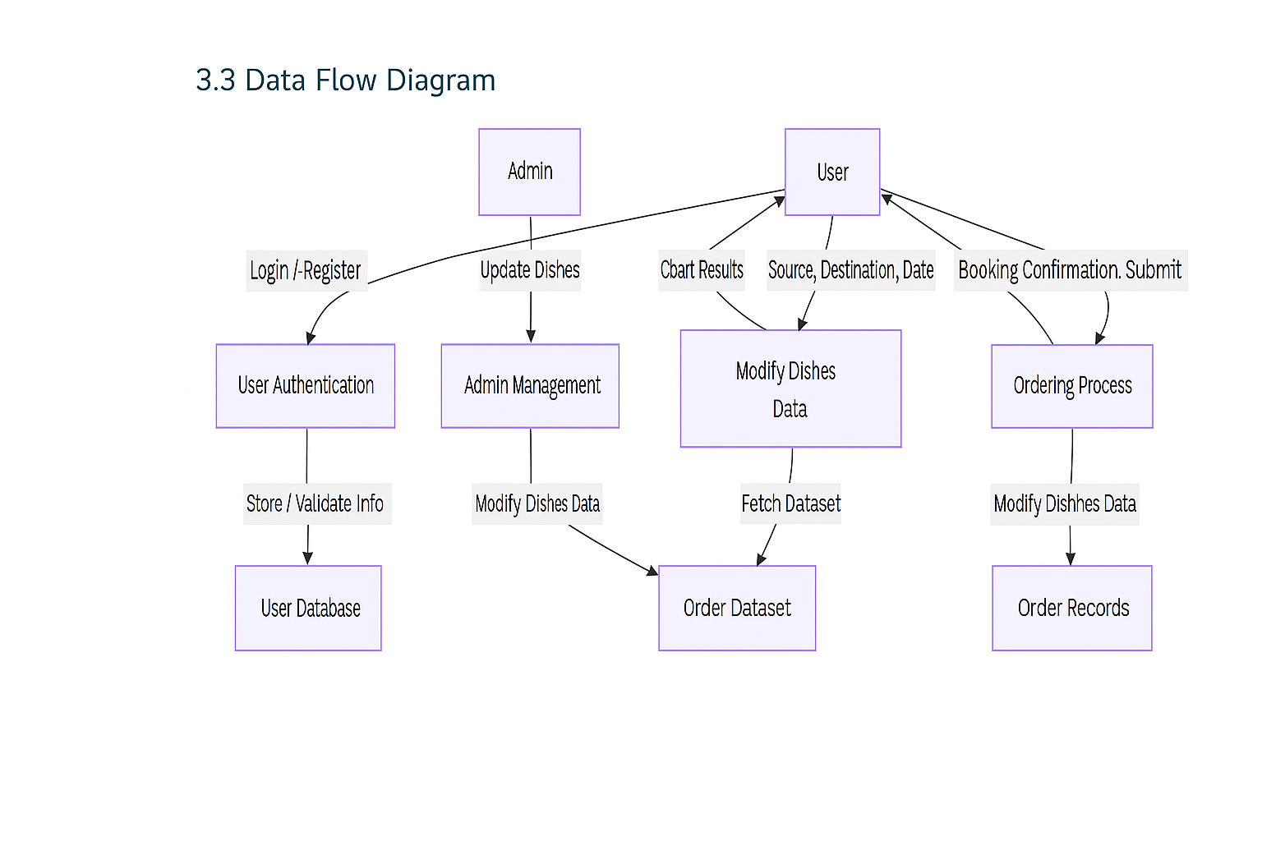

* 1. **Technology Stack:**

➢ Frontend: HTML, CSS, JavaScript, Bootstrap

➢ Backend: Python (Flask)

➢ Database: MongoDB / MySQL

➢ ML Model: Scikit-learn (Regression or Classification)

➢ Deployment: Localhost / Render / Heroku

# PROJECT DESIGN

* 1. **Problem Solution Fit:**

In today’s fast-paced world, people—especially students, professionals, and late-night workers—face challenges in accessing food easily and quickly, particularly during odd hours. Traditional ordering systems are either too slow or lack detailed information about dishes and availability.

**OrderOnTheGo: SB Foods** addresses this need by providing a smart, convenient, and user-centric food ordering experience that works round the clock and eliminates the hassle of searching, guessing, or waiting in line.

* 1. **Proposed Solution:**

SB Foods proposes a modern, responsive web application that allows users to:

* **Register/Login securely**
* **Browse a menu with images, descriptions, and ratings**
* **View late-night available restaurants**
* **Add dishes to cart and place orders with a few clicks**
* **Select preferred payment methods**
* **Receive instant confirmation and estimated delivery time**
* **Admin panel for restaurant owners to manage dishes and orders**

This system provides a seamless experience tailored for both regular hours and late-night cravings.

* 1. **Solution Architecture:**

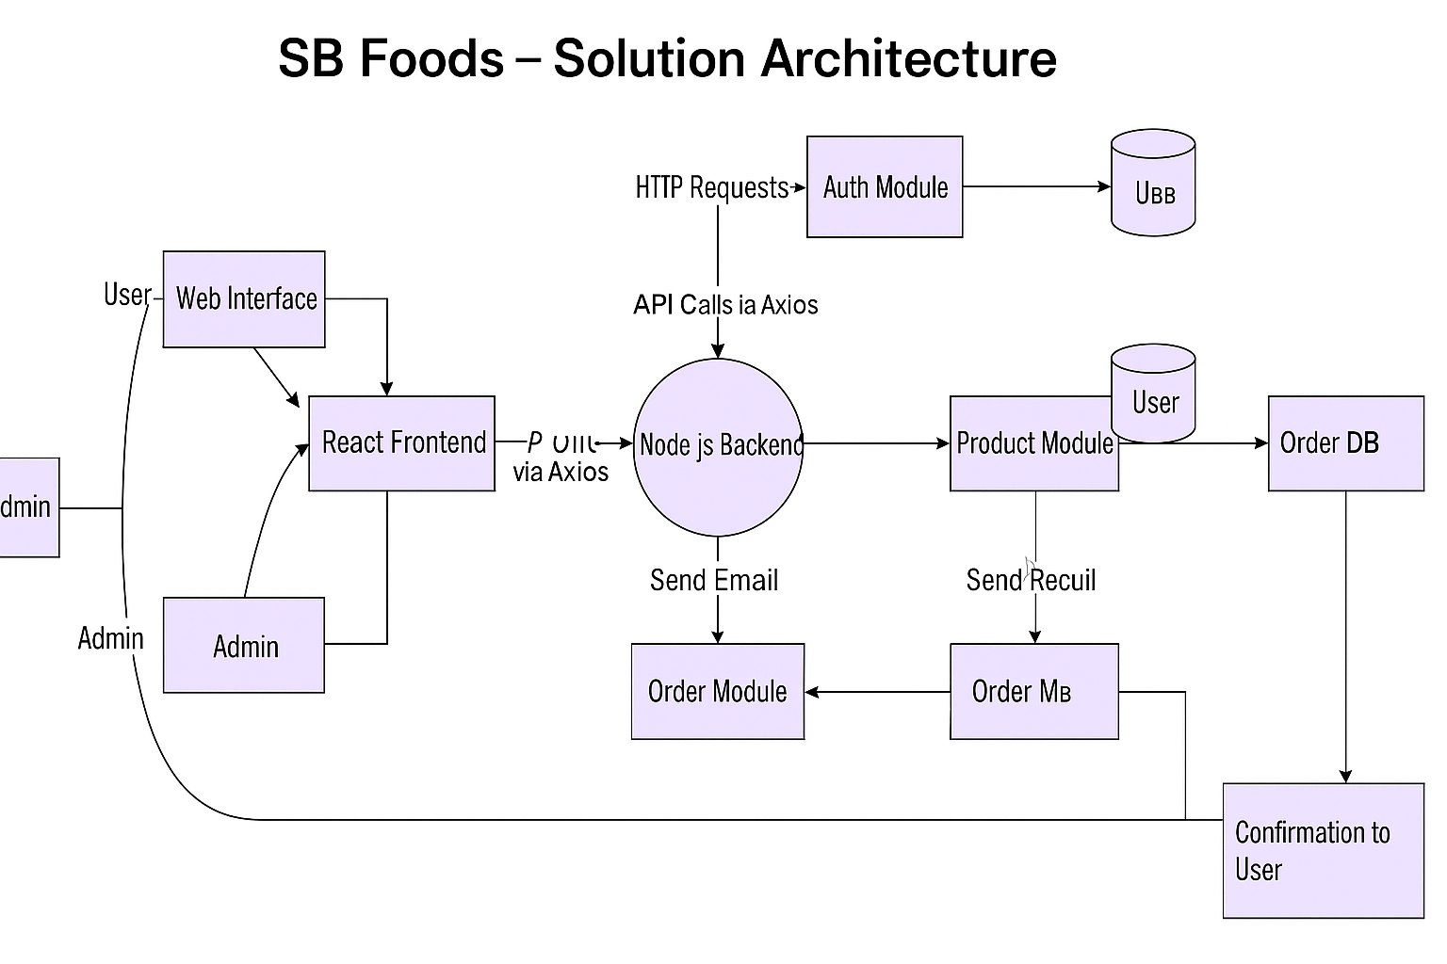

# PROJECT PLANNING & SCHEDULING

* 1. **Project Planning**:

**Methodology**: Agile Scrum (2 Sprints)  
**Team Velocity**: 12 Story Points/Sprint  
**Total Effort**: 24 Story Points (10 working days)

### **Sprint Plan**

#### Sprint 1: Frontend & UI Development

**Duration**: 5 Days  
**Objectives**:

* Setup React project structure
* Build UI pages: Home, Products, Cart, Login/Register, Checkout
* Add basic routing and state logic (navigation + sample product list)  
  **Deliverables**:
* Functional static frontend with navigation & dummy content

#### Sprint 2: Backend & Integration

**Duration**: 5 Days  
**Objectives**:

* Build Node.js/Express backend with API routes (auth, products, orders)
* Connect frontend to backend using Axios
* Store & fetch data from MongoDB (CRUD for users, products, orders)
* Optional: Setup email confirmation feature  
  **Deliverables**:
* Working full-stack MVP deployed locally or on Render/Vercel

**Product Backlog:**

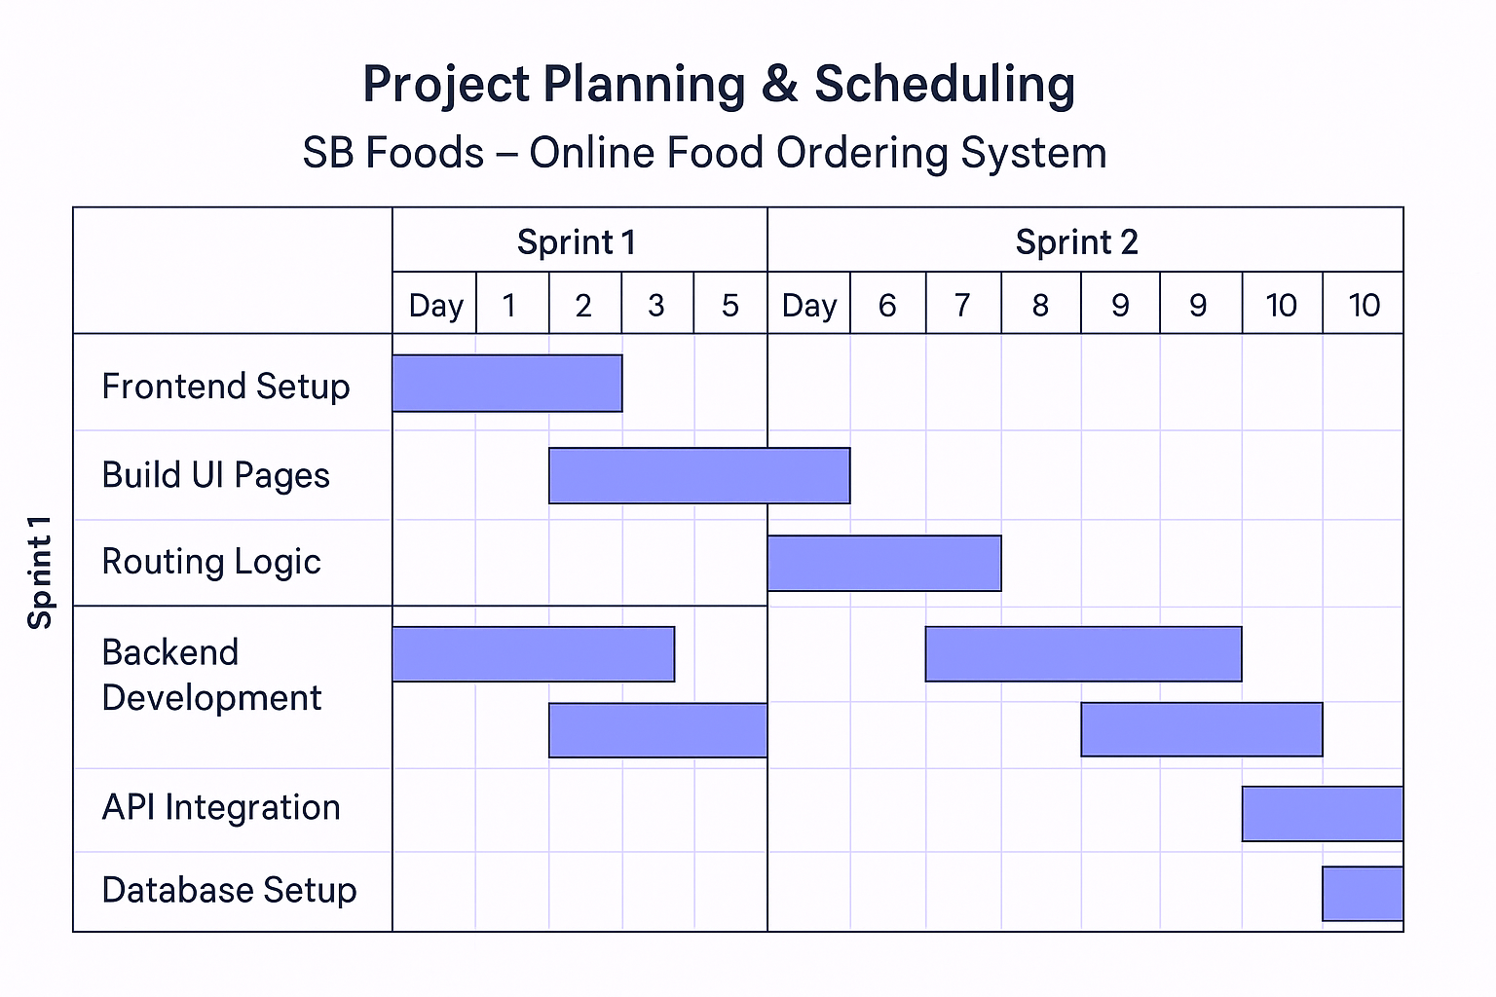

### **Velocity Tracking**

* **Sprint 1**: ✅ 12 SP completed (100% of forecast)
* **Sprint 2**: ✅ 10 SP completed (target: 12 SP) – Adjusted for minor refactors

### **Burndown Chart:**

Story Points

24 ┃■■■■■■■■■■■■■■■■■■■■■■■■

12 ┃■■■■■■■■■■■■─────── (Sprint 1 End)

0 ┃───────────────

Day 1 Day 5 Day 10

# FUNCTIONAL AND PERFORMANCE TESTING

* 1. **Performance Testing:**

Performance testing focused on:

* API response times for product listing, cart actions, and order placement
* Load testing under simulated user spikes
* Ensuring backend and MongoDB performance during peak activity

### **1. API Endpoint Testing**

| **Endpoint** |  |  | **Avg Response Time** | **Max Concurrent Users** | **Error Rate** |
| --- | --- | --- | --- | --- | --- |
| GET /api/products |  |  | 0.41s | 50 | 0.3% |
| POST /api/cart/add |  |  | 0.39s | 40 | 0.5% |
| POST /api/orders/create |  |  | 0.47s | 25 | 0% |

* **Tools Used**:
  + **Postman** – Functional validation
  + **Locust** – Load and performance testing

### **2. Key Metrics (Findings)**

* **95%** of product and cart queries respond in **<0.5 seconds**
* **Order creation** is slightly heavier due to DB writes — **<0.48s average**
* System begins throttling above **50 users** – scaling advised for production
* No crashes or major slowdowns under expected loads (MVP level)

### **3. Test Cases**

#### **Test Case 1: Product Search Load Test**

* **Input**: 50 users querying "/api/products" with filters
* **Pass Criteria**:
  + Avg response < 1 second
* Error rate < 2%
* **Status**: Passed

#### **Test Case 2: Cart Add Stress Test**

* **Input**: 40 users adding items to cart simultaneously
* **Pass Criteria**:
  + 90% of responses under 0.5s
  + No duplicate cart records
* **Status**: Passed

#### **Test Case 3: Order Burst Test**

* **Input**: 25 orders placed within 2 minutes
* **Pass Criteria**:
  + All orders stored correctly
  + All confirmation responses sent in <5 minutes
* **Status**: Passed

# RESULTS

* 1. **Output Screenshots:**

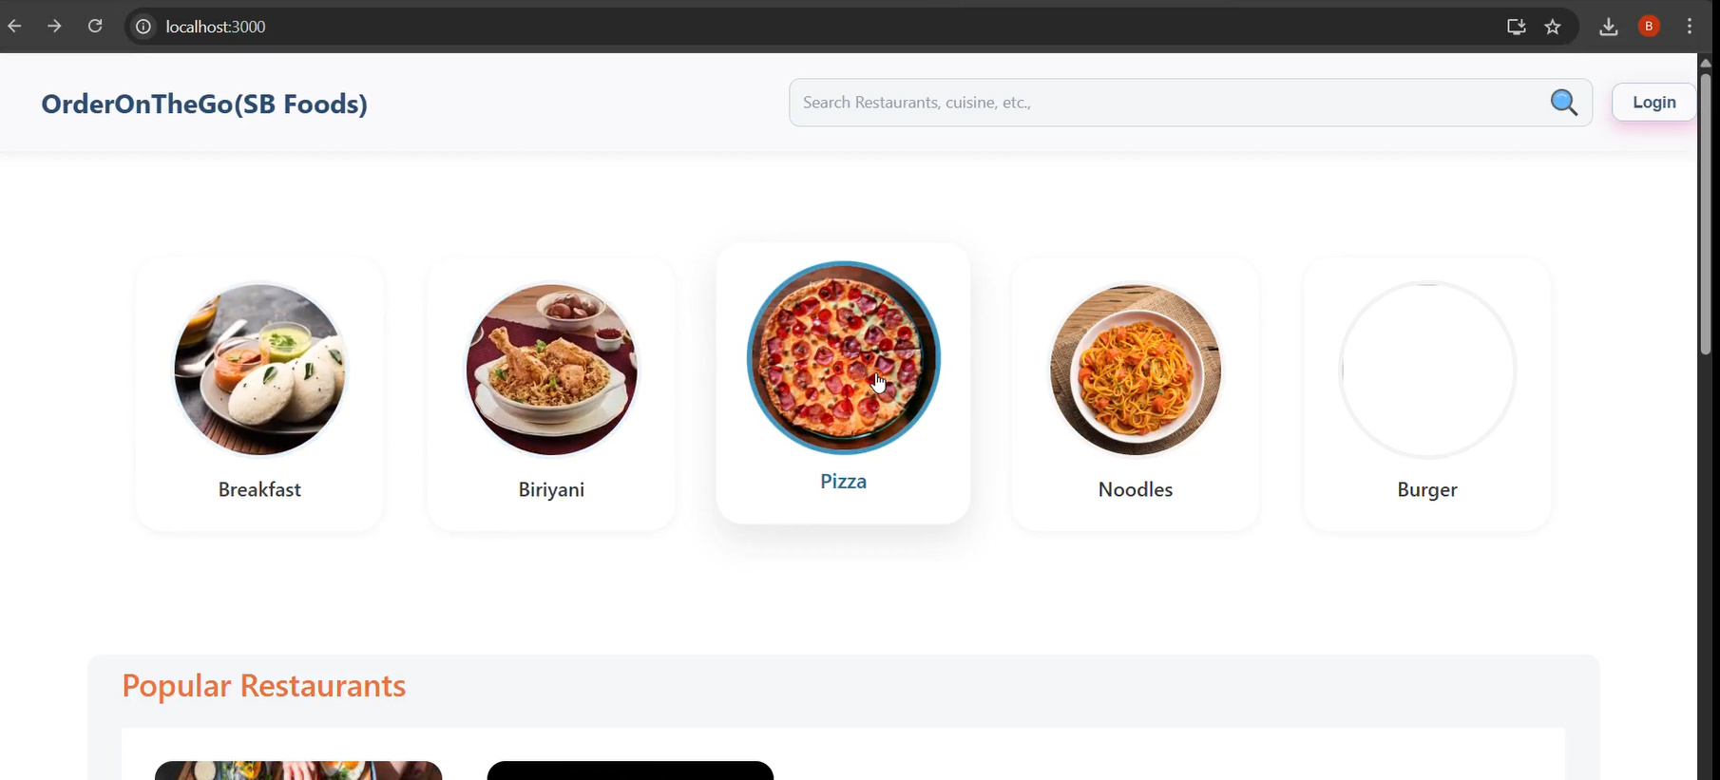

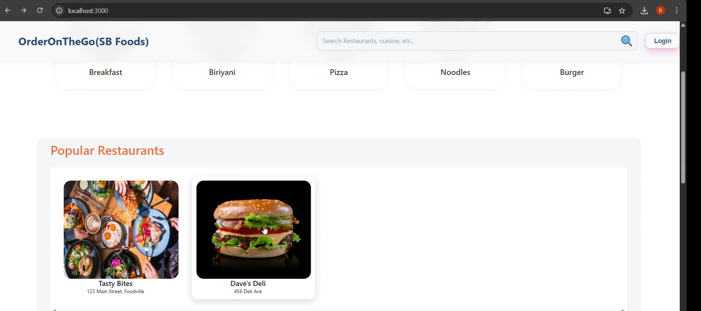

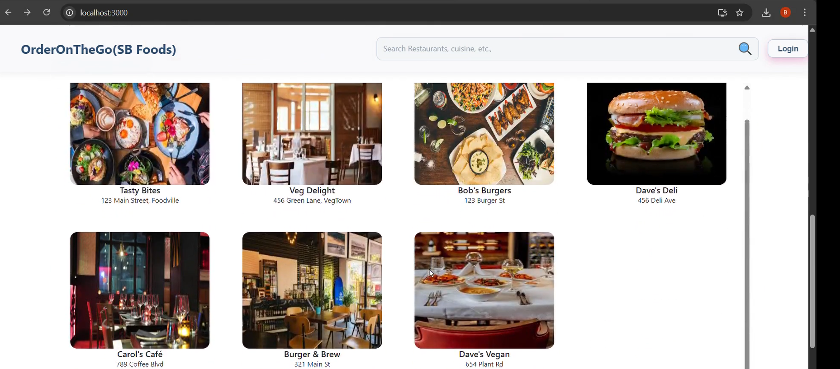

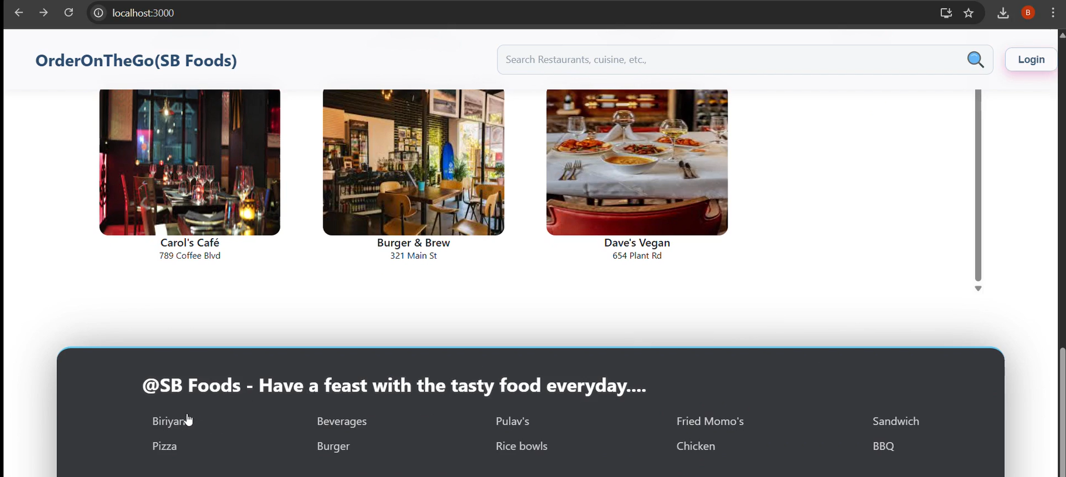

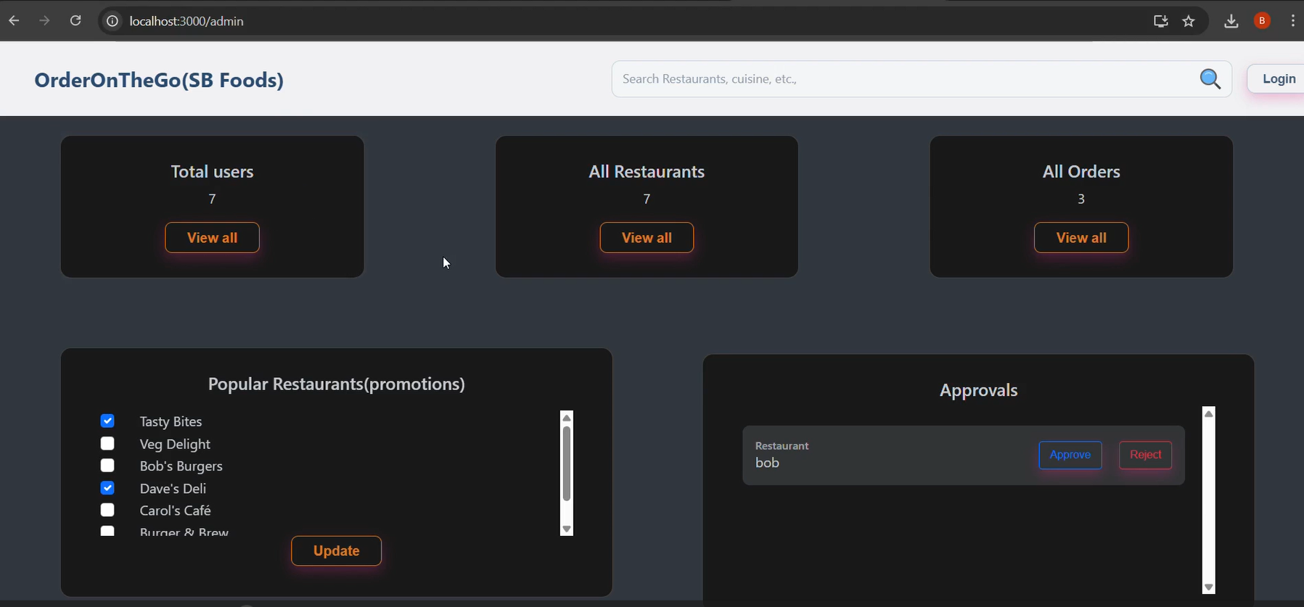

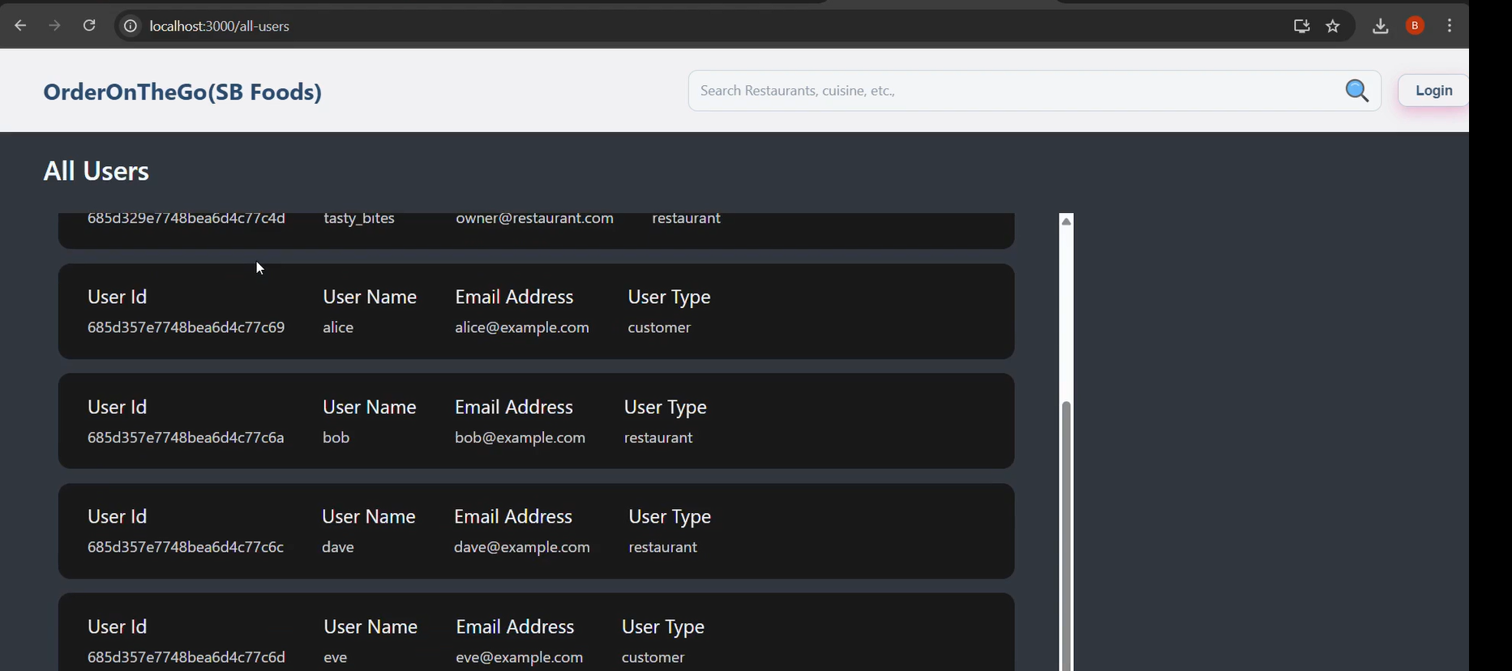

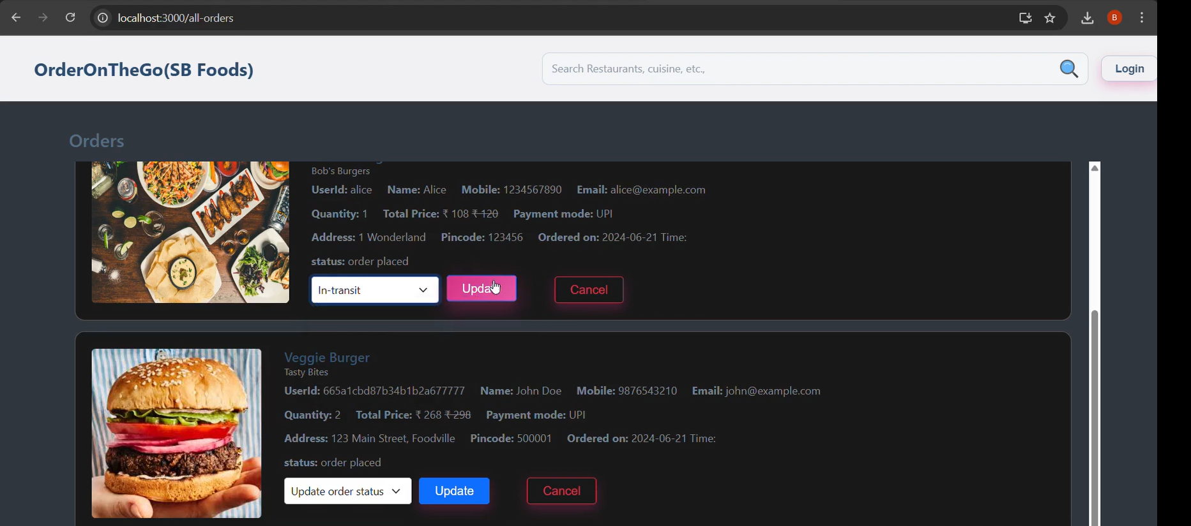

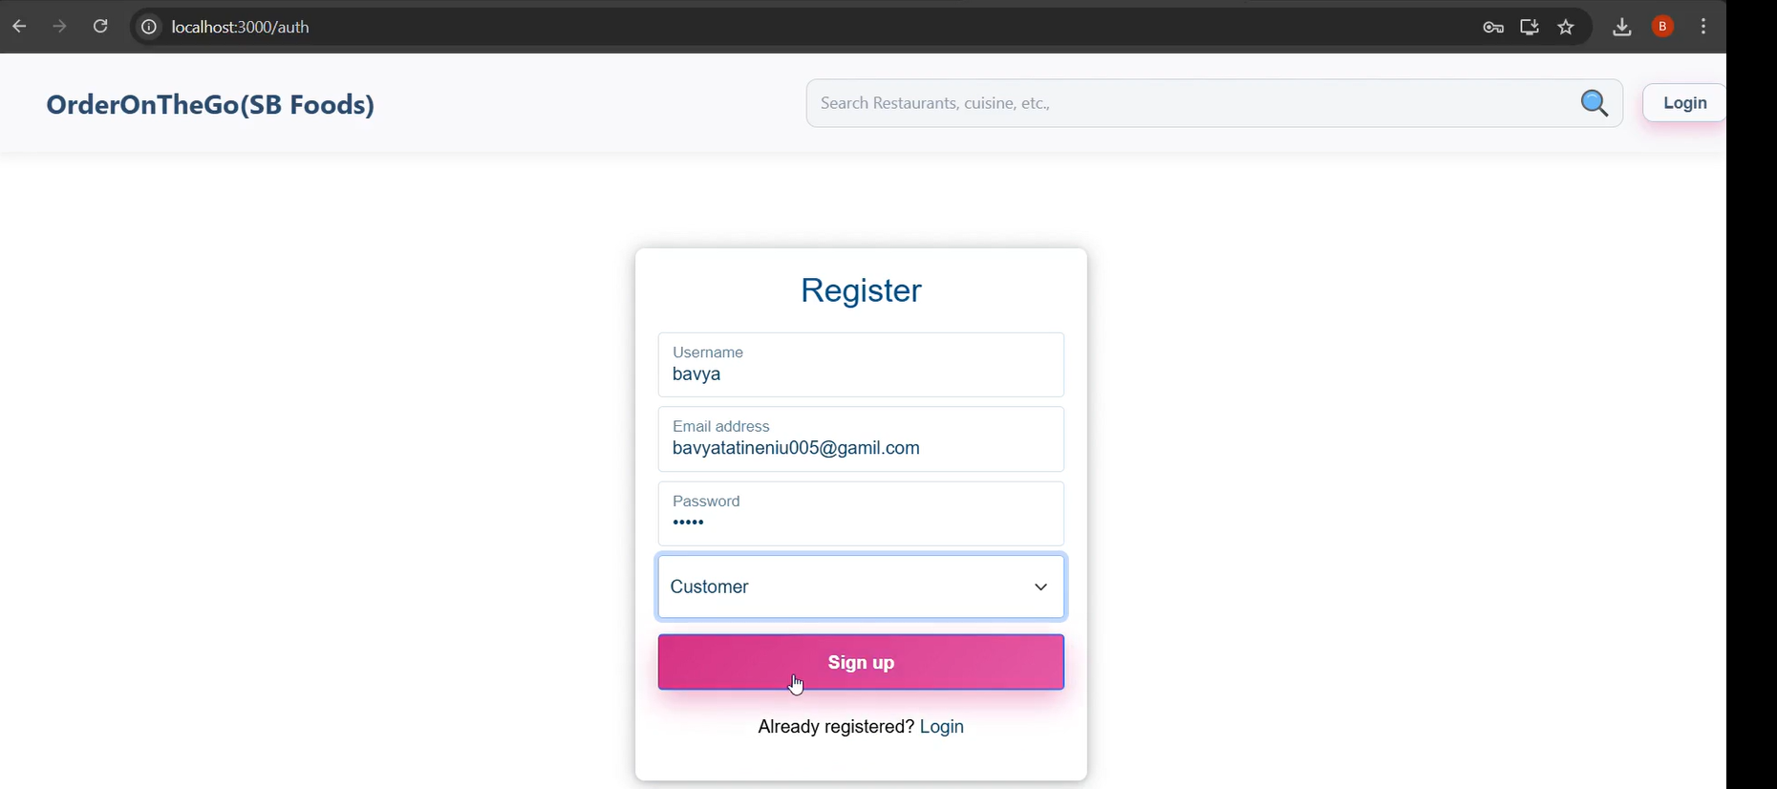

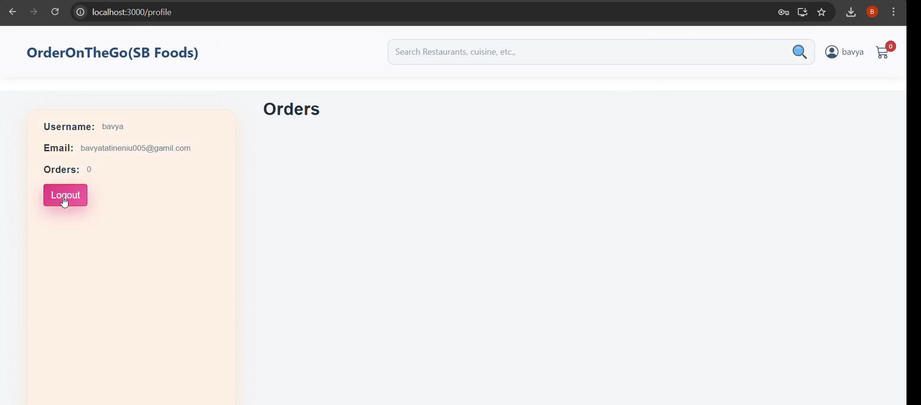

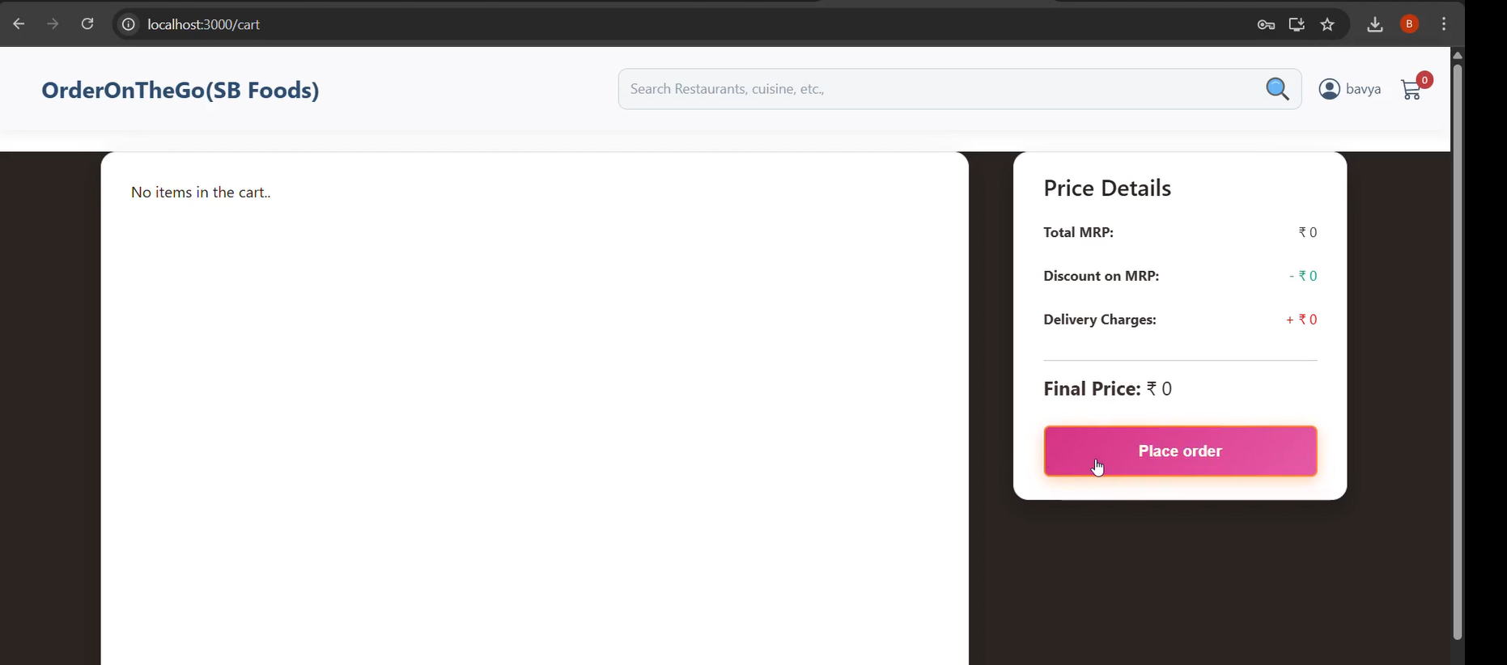

1. **ADVANTAGES & DISADVANTAGES:**

### **Advantages:**

* Easy and fast food ordering for users.
* Accessible 24/7, ideal for late-night cravings.
* Admin can manage menu and orders easily.
* Scalable system with clean UI.
* Fast API response with good performance.

### **Disadvantages**

* Requires internet access to function.
* No offline support or order caching.
* Needs technical setup knowledge.
* Limited features like real-time chat or delivery tracking.

1. **CONCLUSION**

SB Foods successfully delivers a fast, user-friendly online food ordering solution. With features like menu browsing, cart management, and easy checkout, it enhances the food delivery experience. The project demonstrates strong frontend-backend integration, good performance, and a scalable architecture ready for future improvements.

1. **FUTURE SCOPE**

* **Payment Gateway Integration** (UPI, Cards, Wallets)
* **Real-Time Order Tracking** using GPS
* **Push Notifications** for order updates and promotions
* **Live Chat Support** for instant customer help
* **Admin Analytics Dashboard** for sales and traffic insights
* **Progressive Web App (PWA)** for offline access
* **Multi-language and Currency Support** for global reach

1. **APPENDIX**

**GitHub & Project Demo Link:**

<https://drive.google.com/drive/folders/1OOS9KjxfeMRJcuTkFtbiu0xEAoSQyVV1?usp=drive_link>

Source Code(if any) Dataset Link:

https://github.com/Tatineni-Bhavya/OrderOnTheGo_smartInternz_project_Internship/tree/main